Azure Synapse Analytics:
Azure Synapse Analytics is unified analytics engine that brings together SQL technologies is used for enterprise Data Wherehouse. Spark is used for bigdata, Data Explorer for log and time series analytics Pipelines for data integration and ETL/ELT, and deep integration with other Azure services such as Power BI, Cosmos DB, and AzureML.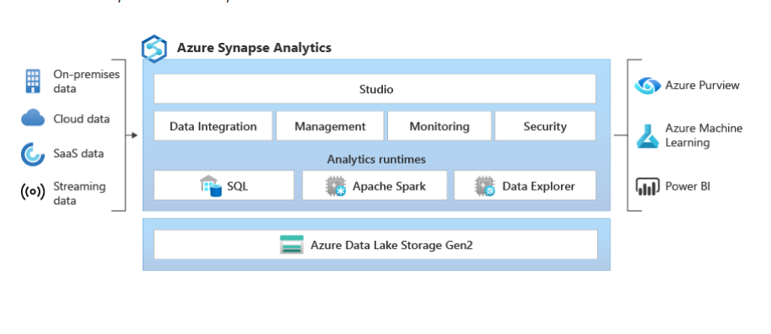
What is synapse analytics pool?
Synapse analytics pool Is distributed query processing engine (process sql queries in distributed manner).
Dedicated Pool: load the data into traditional databases like rdbms.
For dedicated SQL pool, the unit of scale is an abstraction of compute power that is known as a data warehouse unit.
Data warehouse unit:
combination of CPU, memory, and IO. These three resources are bundled into units of compute scale called Data Warehouse Units (DWUs).
Server less Pool: On-demand SQL query processing, primarily used to work with data in a data lake.(tables defined in files. Like .csv,parquet)
Tables defined on files in the data lake are seamlessly consumed by either Spark or SQL.
- Fast, scalable data loading between SQL and Spark databases.

Synapse analytics architecture:

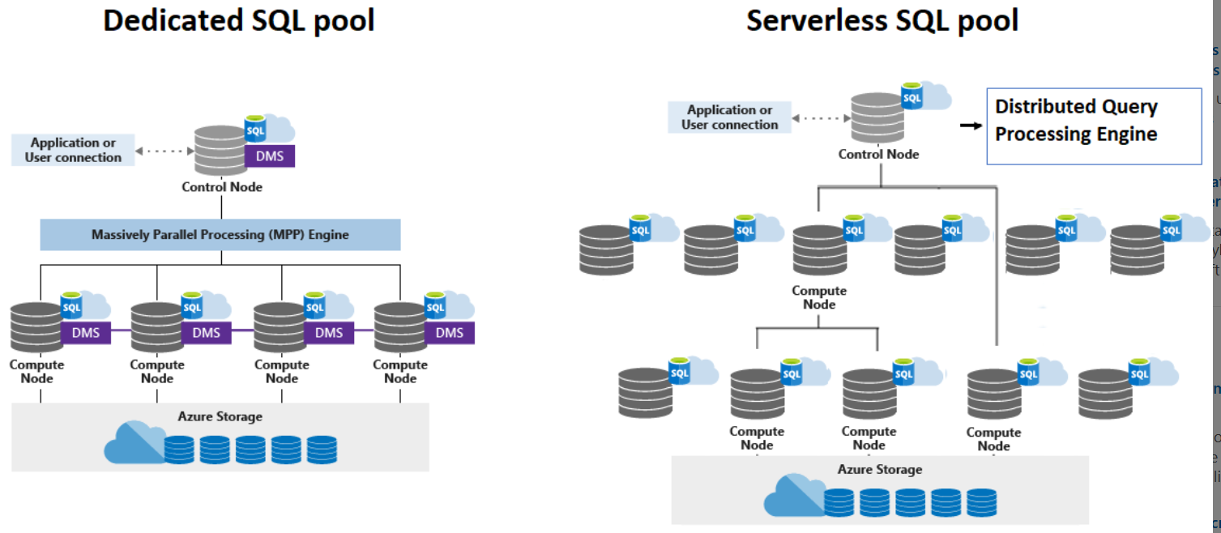
In azure synapse analytics especially dedicated sql pool two key components are there 1) control node 2) compute node.

Control Node:
The control node acts as the central point, receiving queries and orchestrating their parallel processing. It also hosts the distributed query engine, which optimizes queries for parallel execution.
Compute node:
The compute nodes, on the other hand, are responsible for performing the actual computations and storing the data in Azure Storage.

DMS (Data Movement Service):
The control node runs an instance of the DMS, coordinating data movement between itself and the compute nodes.

Tip: no of compute nodes limit 1 to 60

Spark Pool:
Spark pool is used to work with spark.
The benefit of creating spark pool in azure synapse analytics.
- Speed and efiicinecy
- Ease of creation
- Ease of use
- Rest API
- Support adls
- Integration with third party IDEs
- Scalability

Azure synapse analytics screen shots:

Home screen
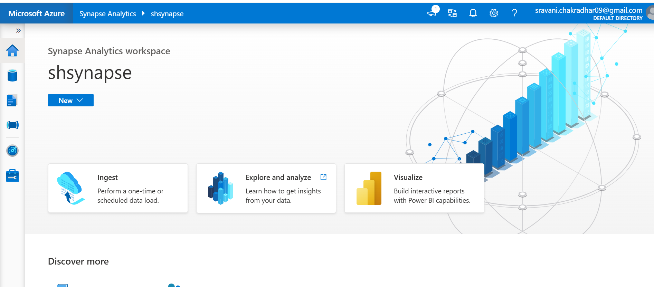
Data Tab:
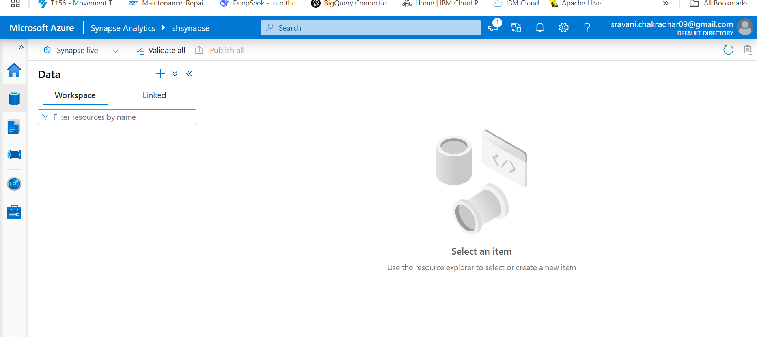

Developtab:
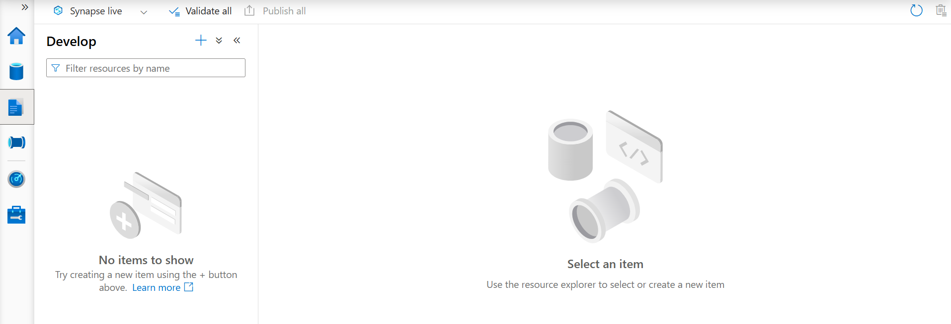
Integrate tab:
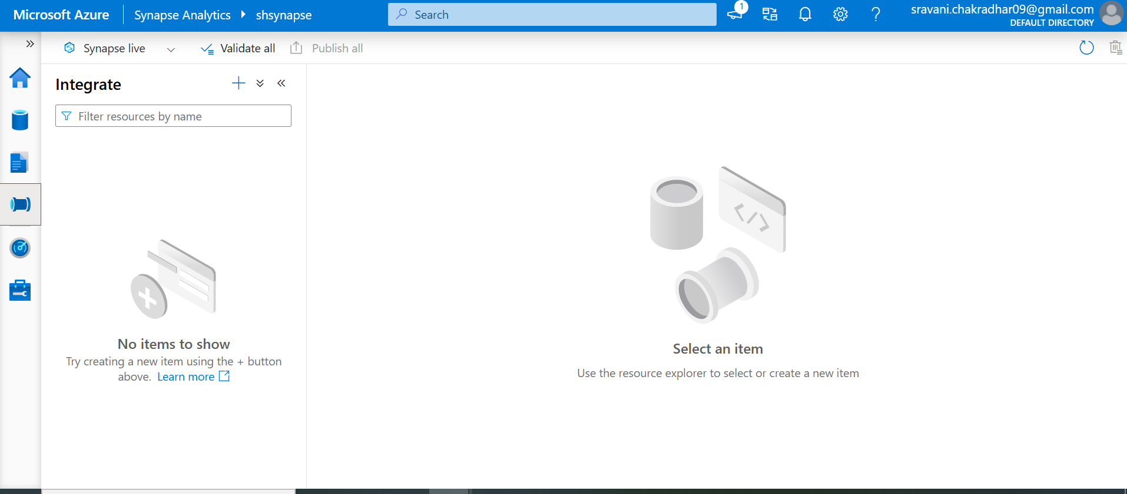

Monitor tab:
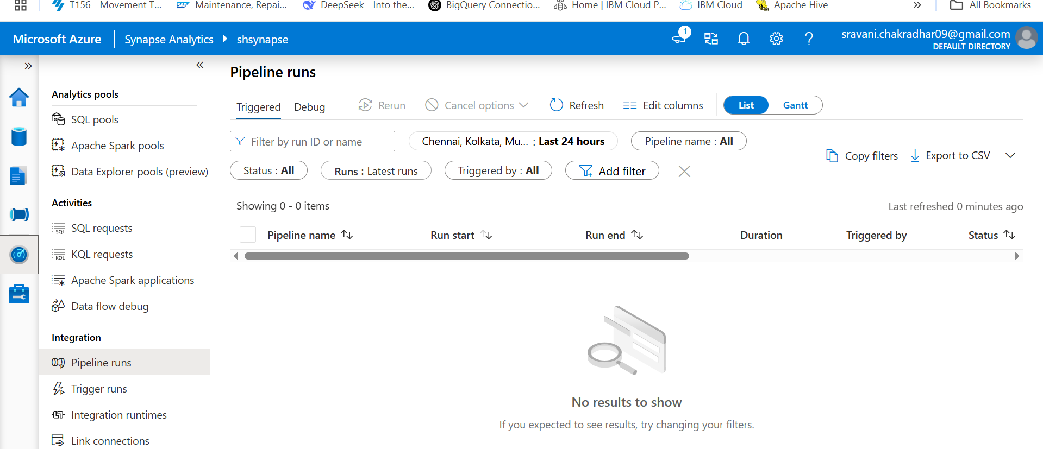
Manage tab:
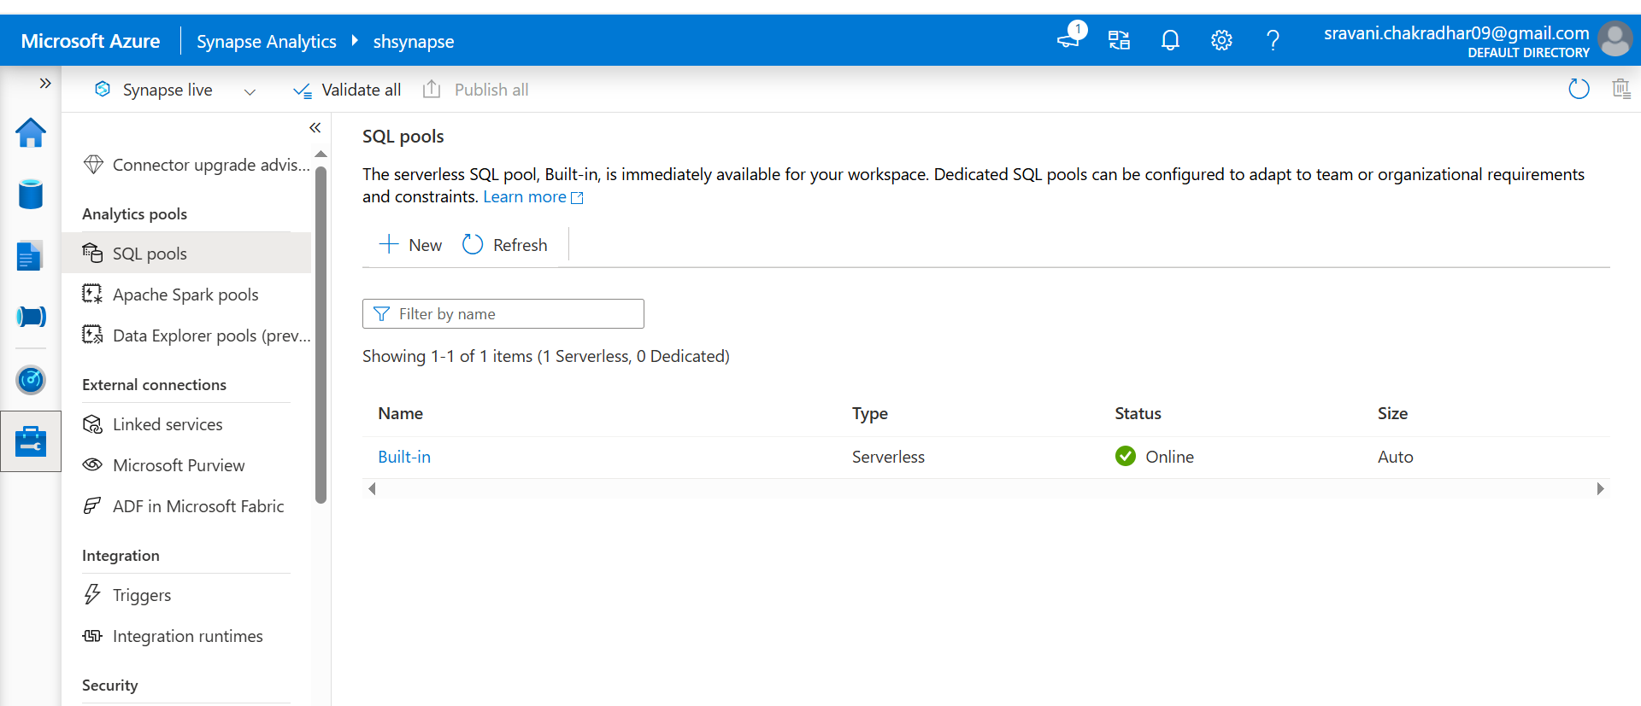
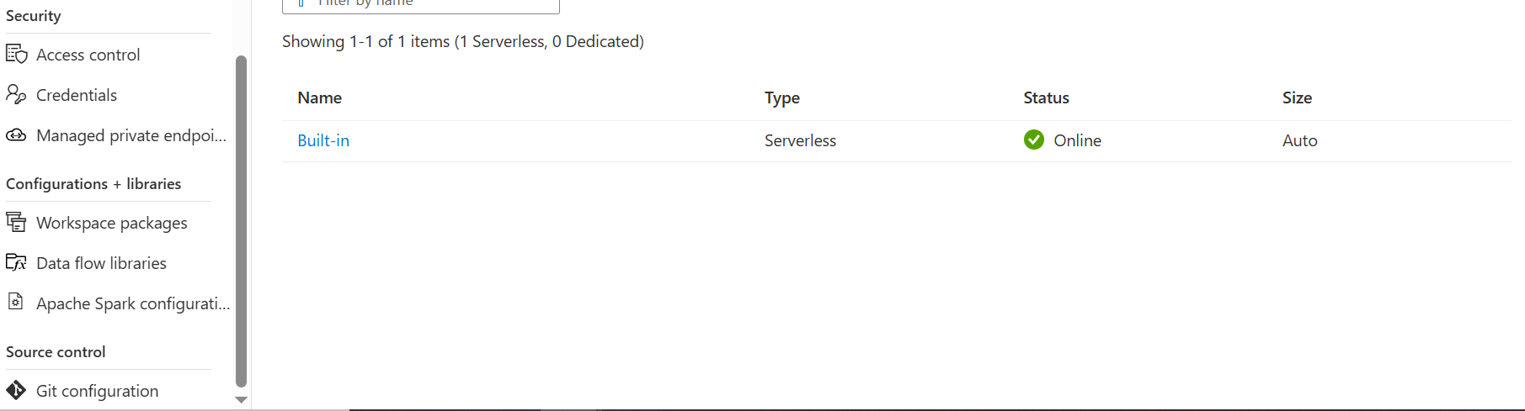

Dirstibuted tables:
In Azure Synapse Analytics, distributed tables represent a logical table that's physically stored across multiple nodes (typically 60) of the dedicated SQL pool. This distribution allows for massively parallel processing (MPP), improving query performance and loading speed.
- Hash Distribution:
Data is distributed based on a hash function, which improves query performance on large fact tables, especially for joins and aggregations.
- Round-Robin Distribution:
Round-robin distribution is useful for improving loading speed.
Rows are distributed evenly across distributions, making it suitable for staging tables and initial loads, but may lead to slower performance on joins compared to hash distribution.
- Replicated Distribution:
Rows are replicated on all nodes, suitable for small, frequently accessed dimension tables, but can lead to higher storage costs and performance issues with writes.

Creating Dedicated SQL Pool: go to Ma select SQL pools and next click on New
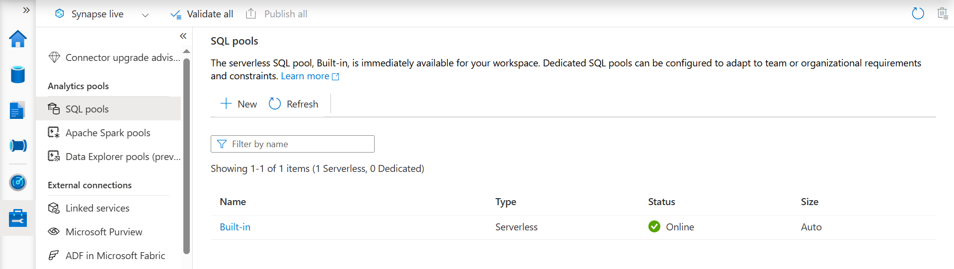

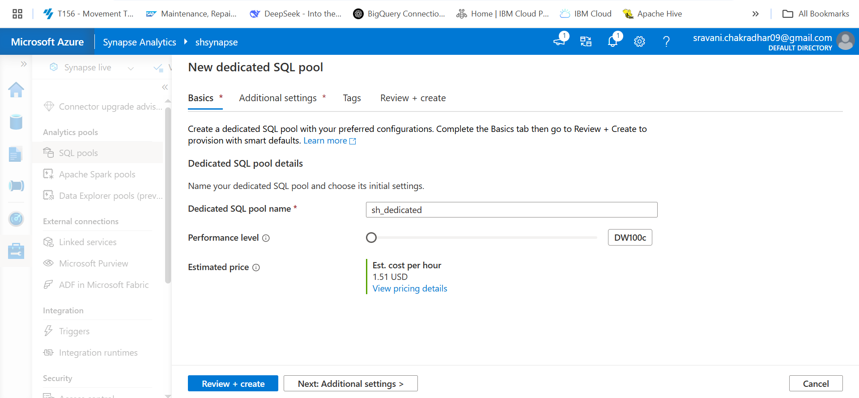

Next check additional settings and tags and finally click on Review + create
After creating dedicated SQLl pool now check the created pool name under data tab check under workspace- under SQL Database.
Next select database and three dots - click on sql script ---click on empty script

By default single record only inserted at time in synapse analytics if we want bulk insert use copy or PolyBase approach
create table emp_round
(
id int,
name VARCHAR(300),
loc VARCHAR(100),
sal INT

)

WITH
(
DISTRIBUTION = ROUND_ROBIN
)

INSERT INTO emp_round VALUES(1,'shankar','hyd',2000)
select * from emp_round;
insert into emp_round (id,name,loc,sal) VALUES (2,'ram','ban',2500)
insert into emp_round (id,name,loc,sal) VALUES (3,'shy','del',3000)
SELECT * from emp_round;
select id, name,loc,sal from emp_round ORDER BY id,sal;

#creating schema
create SCHEMA gold;

---Hash table creation
create table gold.dept(
dept_id int,
dept_name varchar(100),
dept_loc VARCHAR(100)
)

WITH
(
DISTRIBUTION = HASH(dept_id)
)
Detailled information serverless pool
Serverless database (logical data warehouse): when we create serverless database it will create Logical metadata layer on top of files.

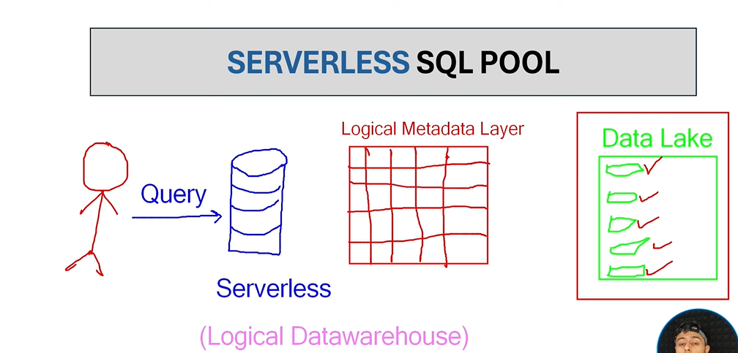

Manage Identity:

In Synapse Analytics, a managed identity provides a unique identity for a Synapse Analytics workspace when connecting to resources. that support Microsoft Entra authentication. This eliminates the need to manage credentials directly and simplifies access to external data sources. It's an identity that can be used to access resources like Azure Key Vault or storage accounts, where data admins securely store credentials.

To connection between external datalakestorage to synpse workspace:
First go to that datalake storage -- click on datastorage click on containers-
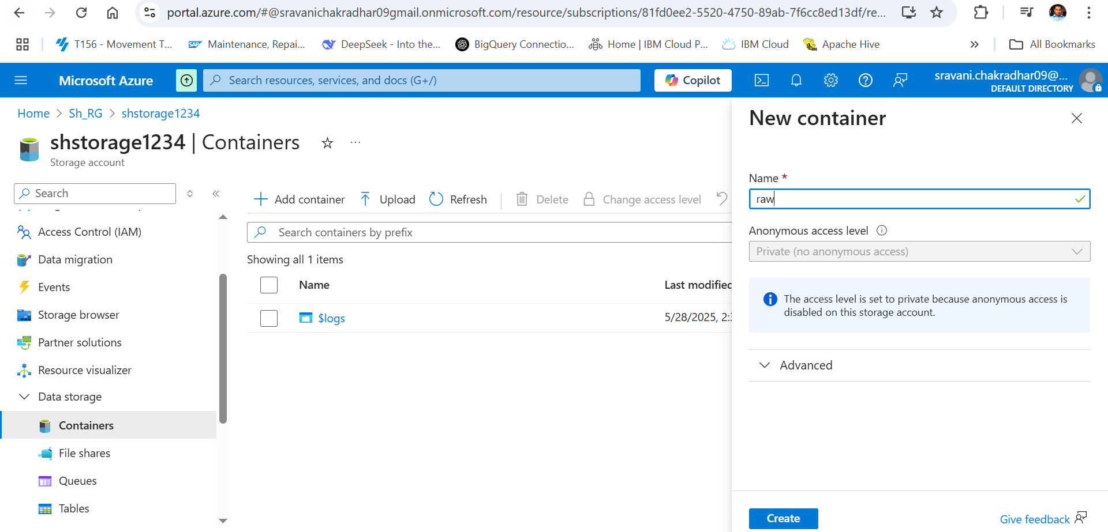

Next go to IAM(identitiy access Management)- click on add role assignment
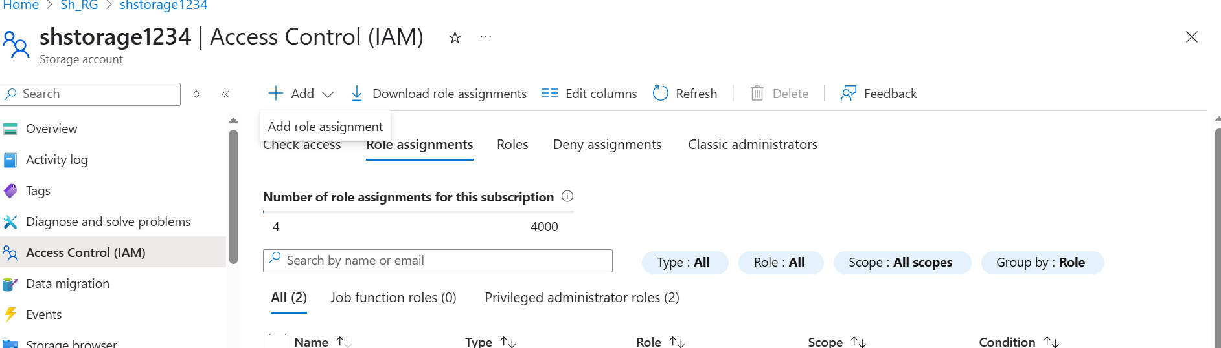

In the search bar - search for storage blob contributor
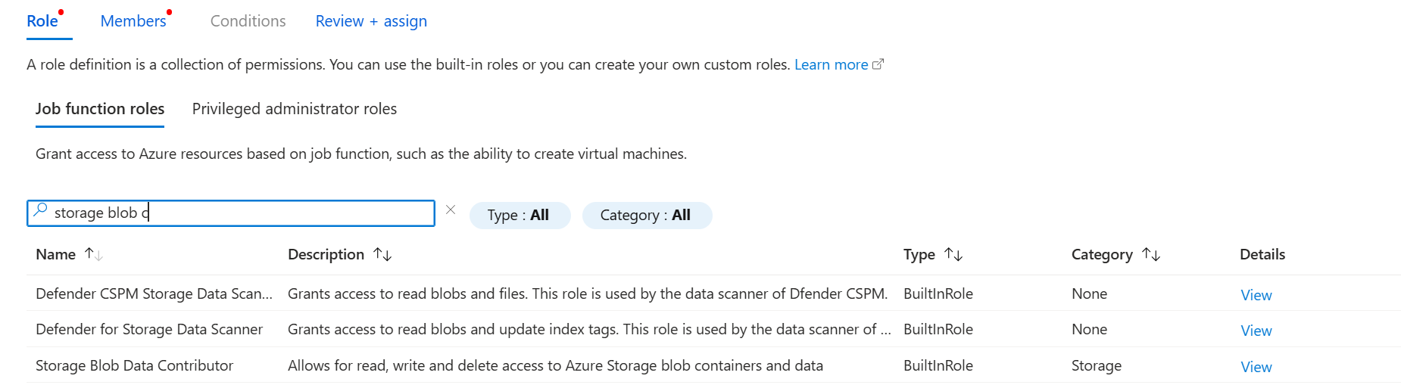
Than select Manage Identity
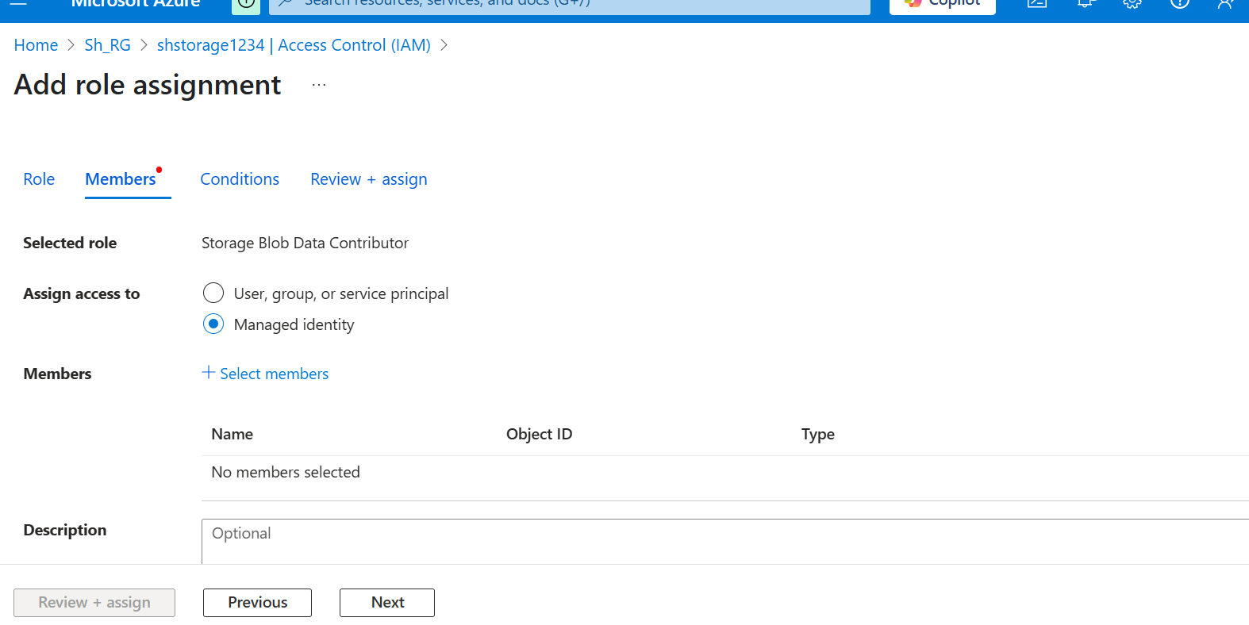
Than click on +select members

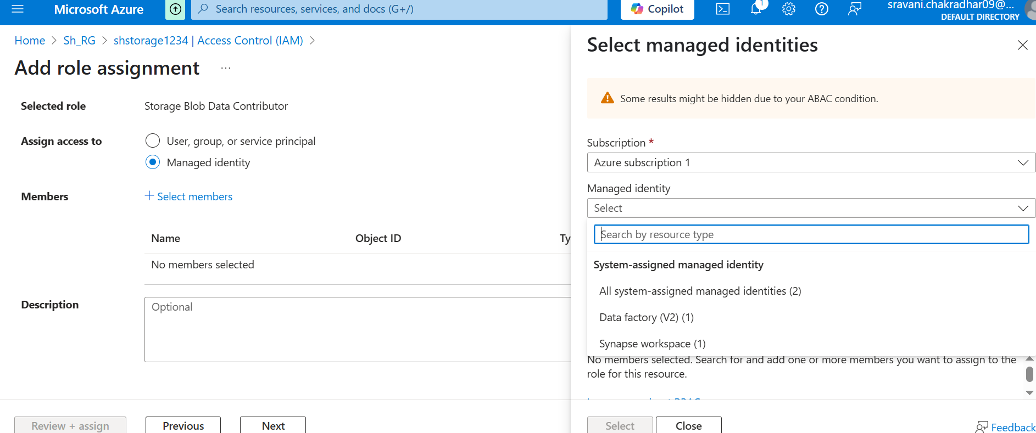

Right side select synapse workspace and click on next and click on review and assign( it will take up to 10 min) to add role
Next go to container click on add directory - give the directory name- and next upload the csv file into that directory:
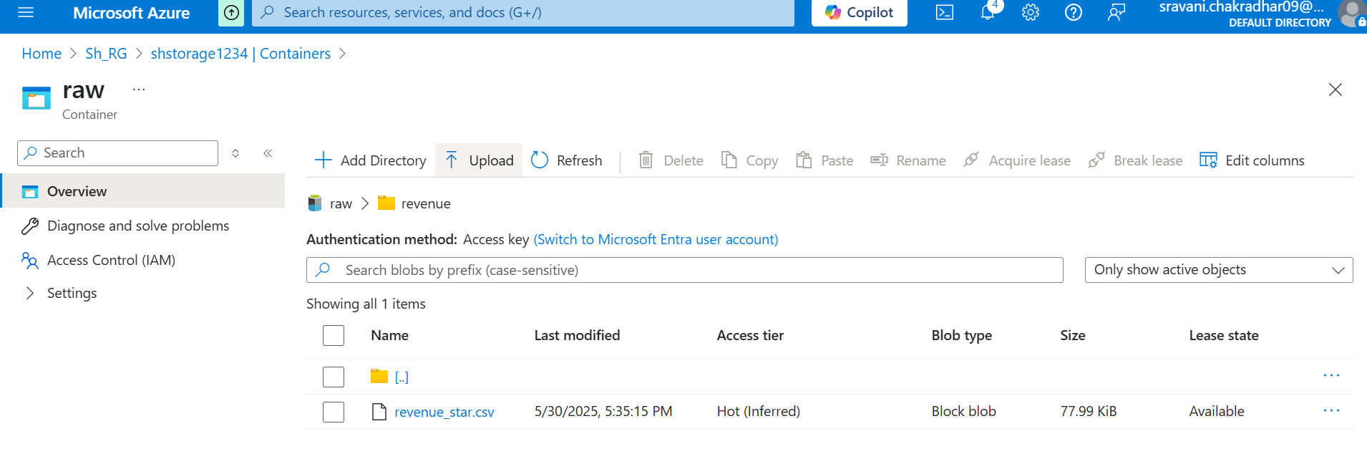

Logical Data warehouse (LDW):(it is used to read and write the data from adls container)
In Azure Synapse Analytics, a Logical Data Warehouse (LDW) is a relational layer built on top of Azure data sources, allowing you to view data from diverse systems without physically moving or transforming it. It uses T-SQL views to provide a relational abstraction, enabling users to query data as if it were in a traditional database, even if the data is stored in a data lake or other sources

Next create one server less database
Go to data tab- click on database - and select serverless and name the database and click on create.
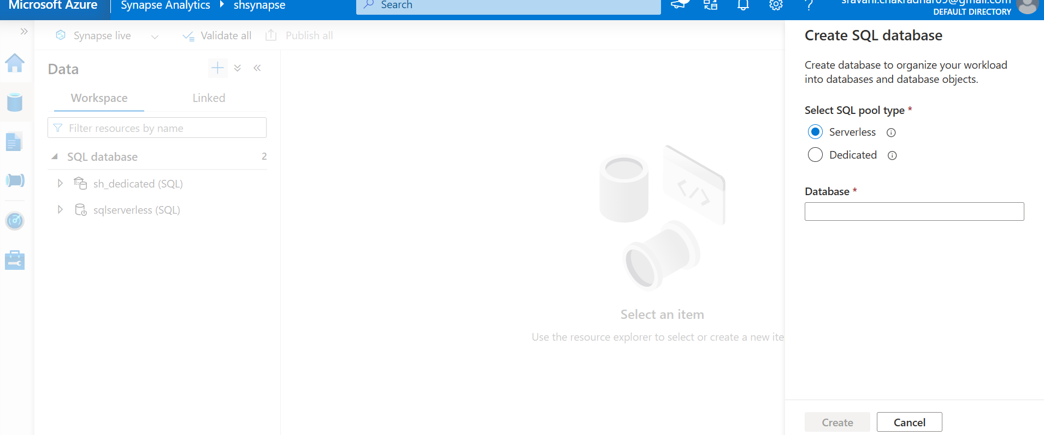

Credential:
Credential creation to know synspase workspace to which one is used ( in azure sas token,keys …etc).
In Synapse Analytics, a credential is essentially a stored set of authentication information, such as a username and password, that allows you to securely access data sources. You need to create credentials because they simplify authentication when connecting to external data sources and help protect your sensitive credentials from being stored in plain text within Synapse
Create masterkey :
In Synapse Analytics, the master key, also known as the database master key (DMK), is a symmetric key used to protect the private keys of certificates and asymmetric keys within the database. It's crucial for securing database-scoped credentials, which are used to access external data sources like Azure Storage accounts.
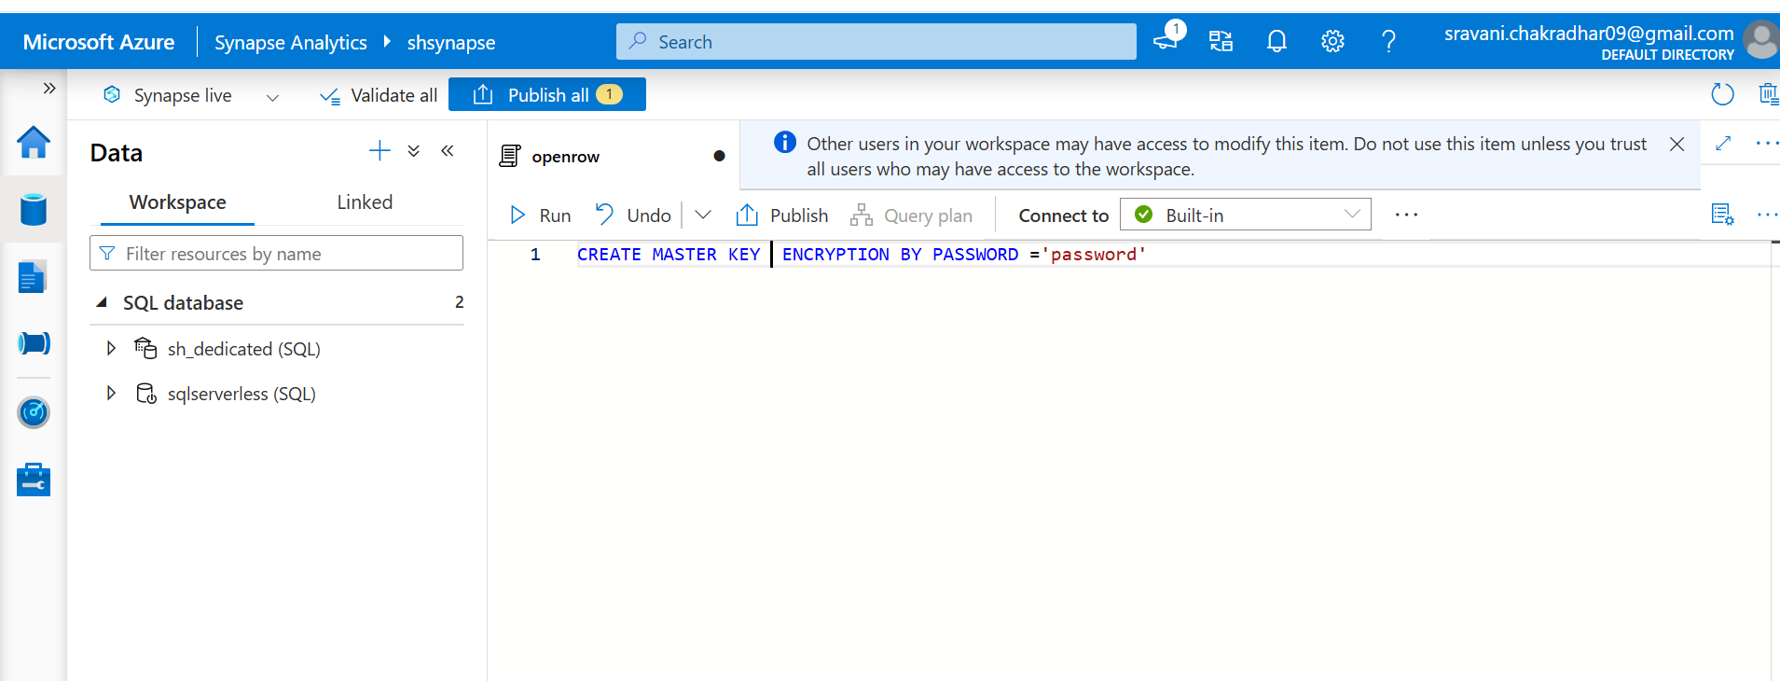
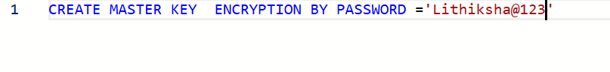
After that click on run command

Now we need to Credential: there are different types of credentials based on requirement.
1)
CREATE DATABASE SCOPED CREDENTIAL MyCredential
WITH IDENTITY = 'Managed Identity';
2)
CREATE DATABASE SCOPED CREDENTIAL MyOtherCredential
WITH IDENTITY = 'SERVICE PRINCIPAL',
CLIENT_ID = 'YOUR_CLIENT_ID',
TENANT_ID = 'YOUR_TENANT_ID',
CLIENT_SECRET = 'YOUR_CLIENT_SECRET';
3)
CREATE EXTERNAL DATA SOURCE MyExternalDataSource
WITH (
LOCATION = 'https://yourstorageaccount.dfs.core.windows.net/',
CREDENTIAL = MyCredential
);

Link:
https://learn.microsoft.com/en-us/sql/t-sql/statements/create-database-scoped-credential-transact-sql?view=sql-server-ver16

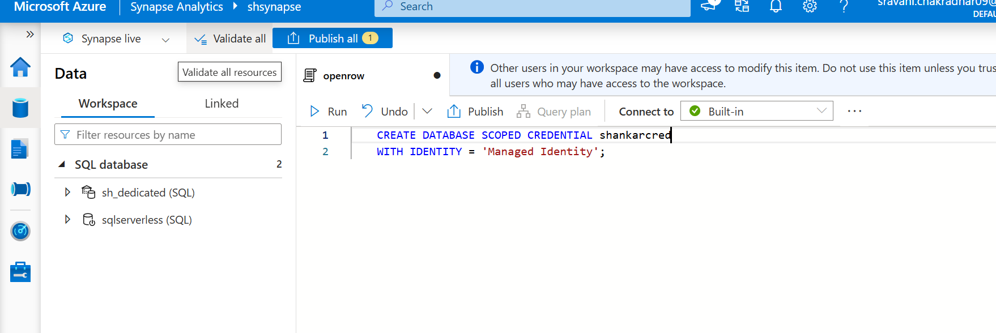

And click on run

Now we need to create external data source:
For that first we need to go folder in adls and go to file click on 3 dots and click on properities and select url; and paste below location in screen shot
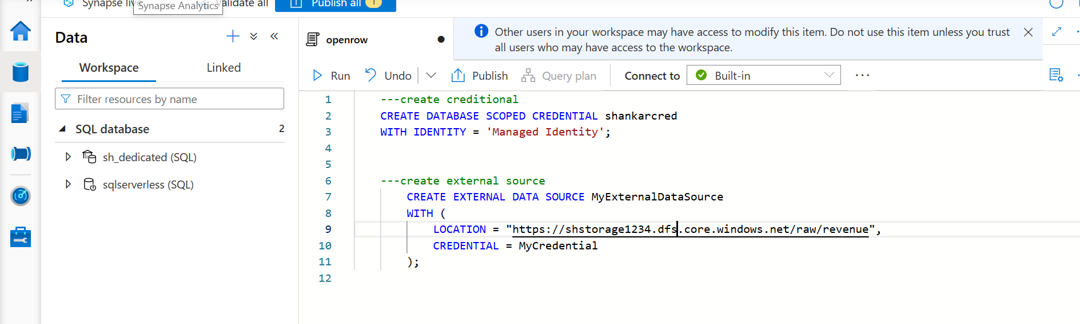

2) method this is the method is used best way while working in large projects:
for that in synpase workspace click on Manage tab and clik on Linked service

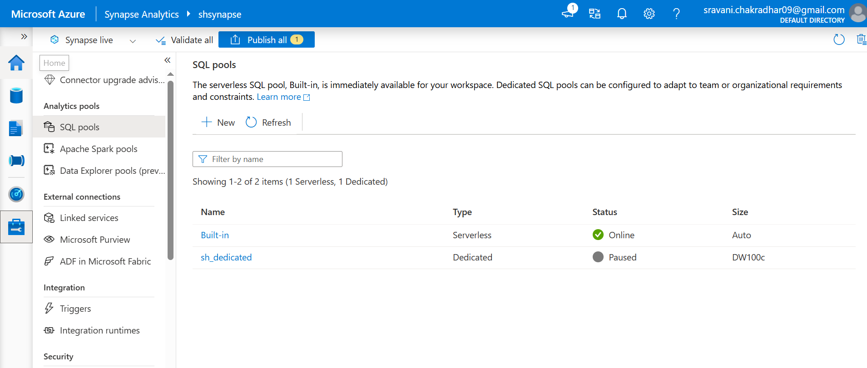

Select adls gen 2 beause we are using adls storage gen 2 not blob
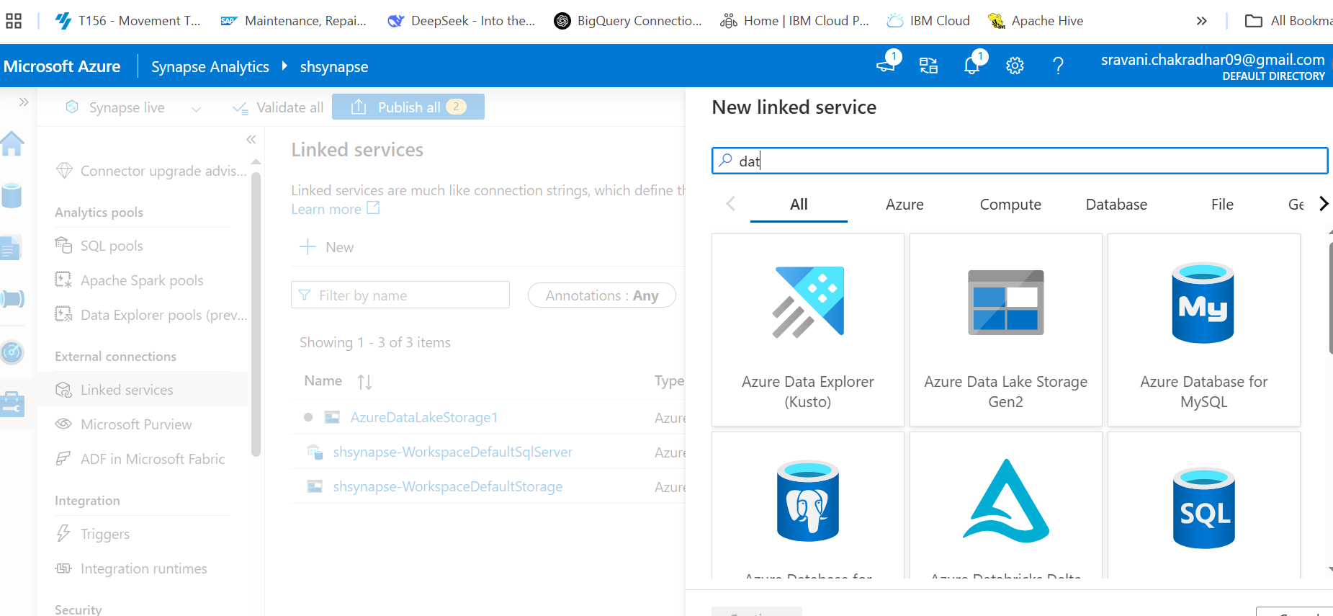

Click on continue

Give all the credintials
But Authenication type is select system managed identity
And give storage account name
And click on create
Now go to data tab:
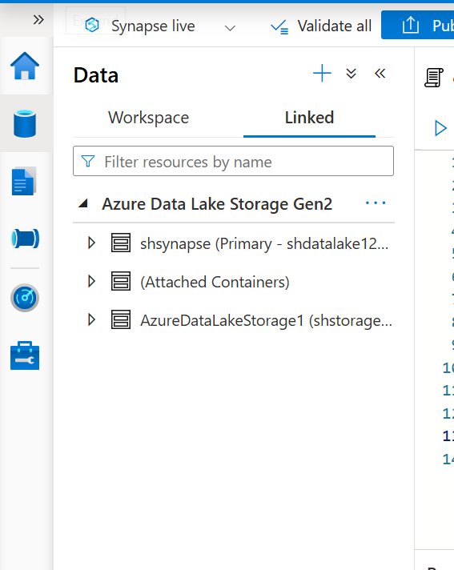

To see the what we create
Our csv file
Right click on that file -- click on propities
Select url
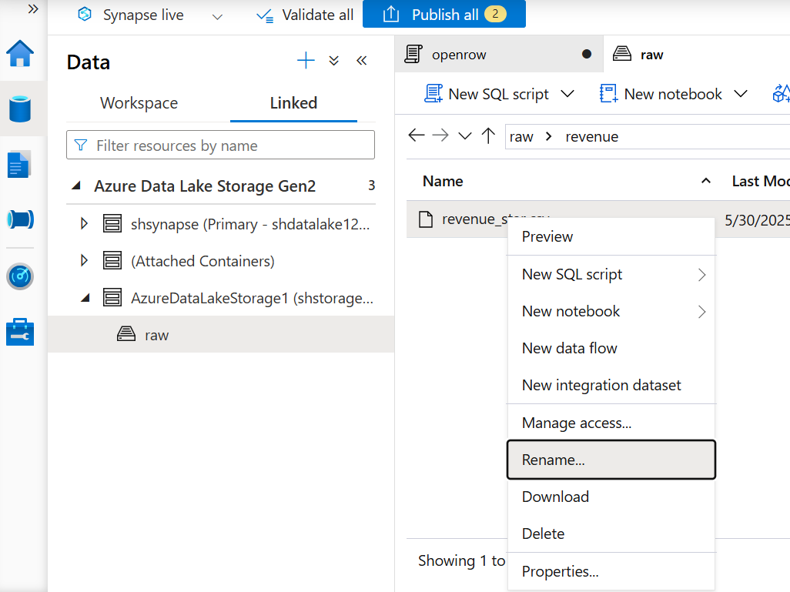
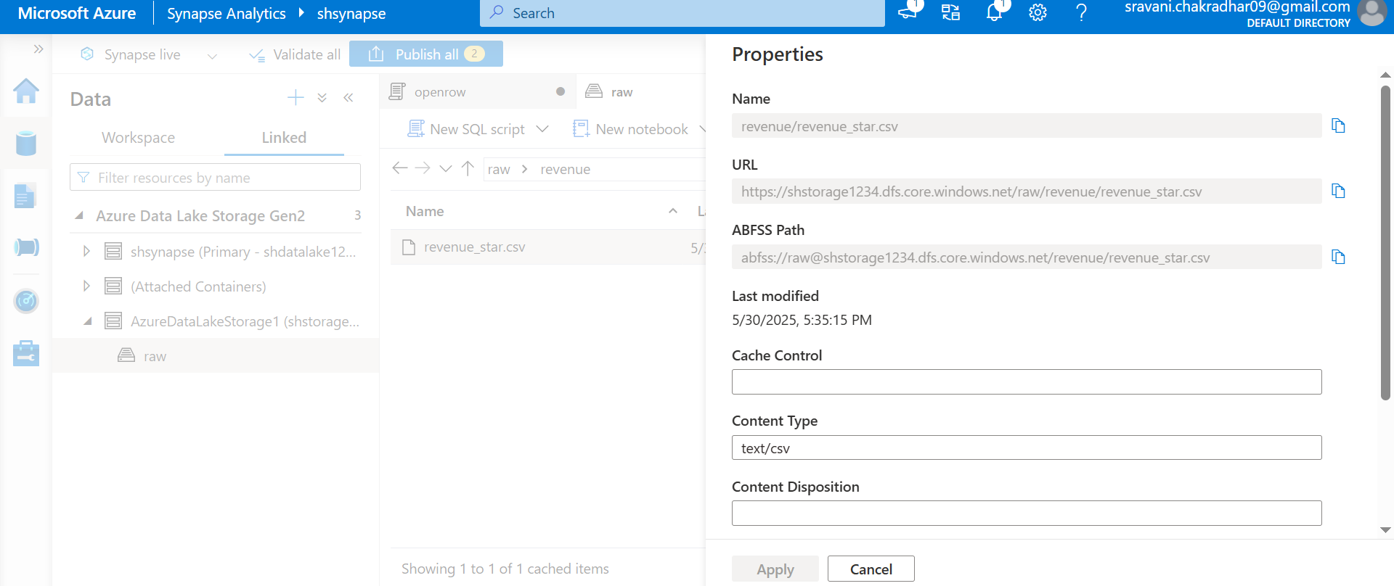

Copy url and paste the url and small change instead of including file path u only keep container level
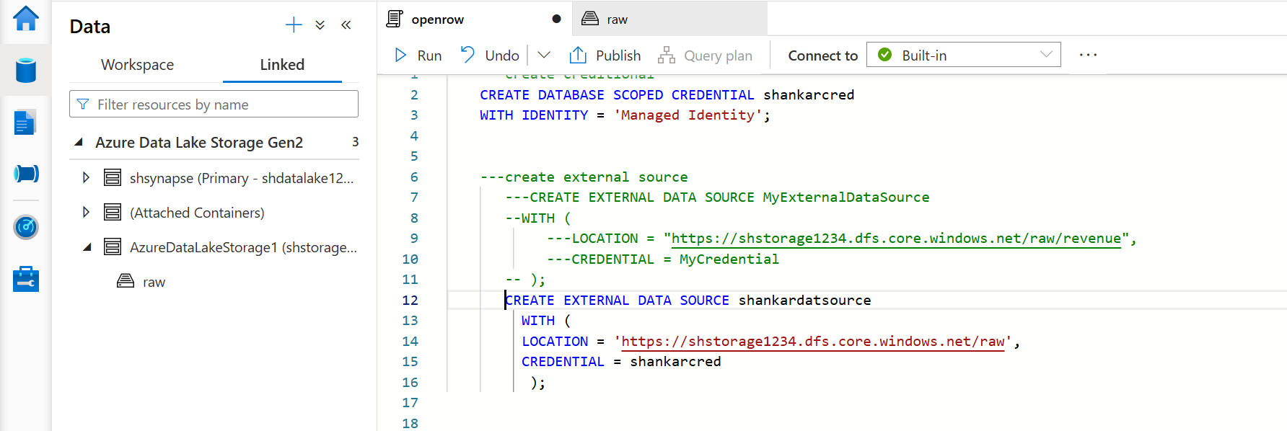

Openrowset():
In Azure Synapse Analytics, OPENROWSET is a function used to query data from external data sources, including Azure Storage, without loading it into a Synapse SQL pool. It allows you to treat external data files (like Parquet, CSV, or JSON) as if they were tables, enabling you to run SQL queries against them directly.
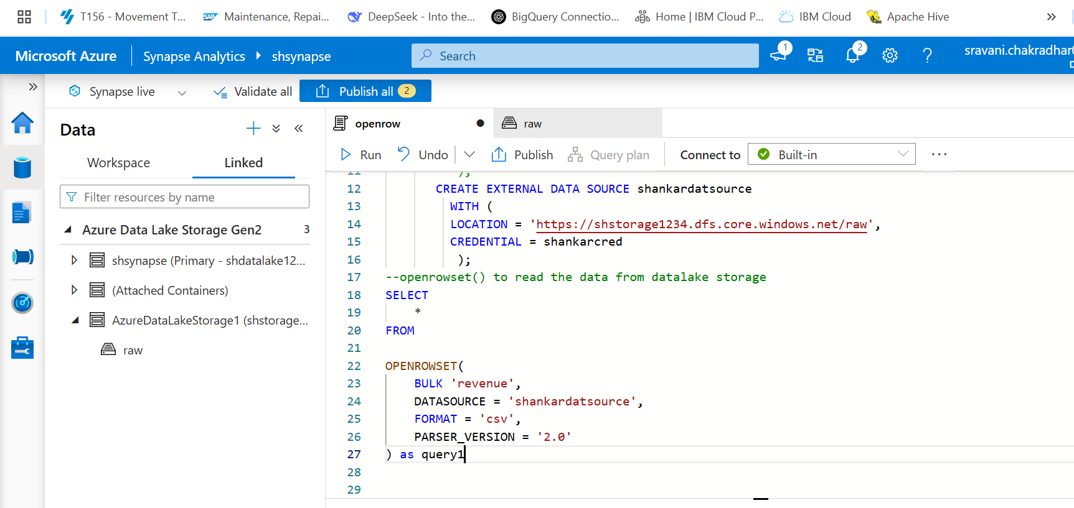

Now click on run and see the data in table format from csv file without creating table.
With column header I wanted
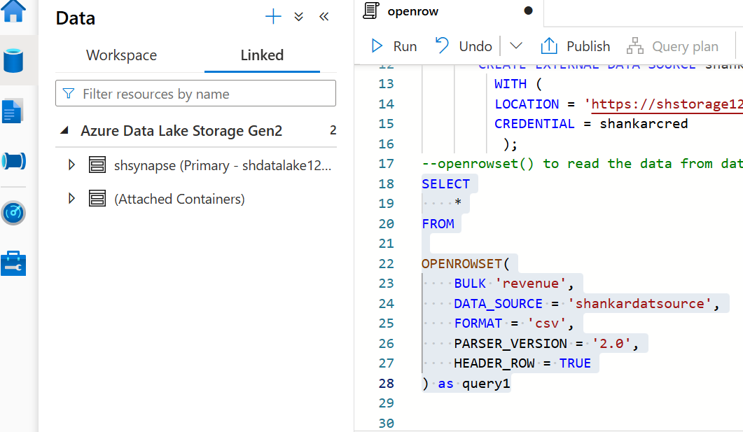
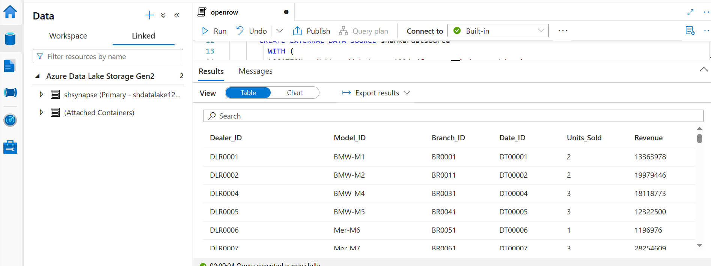

Creating external file format:

To create an external file format in Synapse Analytics, you use the CREATE EXTERNAL FILE FORMAT Transact-SQL statement. This statement defines the format of the data stored in external sources like Azure Blob Storage or Azure Data Lake Storage. You'll specify details like the format type (e.g., CSV, Parquet, Delta) and any compression methods used.
Syn:
-- Create an external file format for CSV files
CREATE EXTERNAL FILE FORMAT CSV_FILE_FORMAT
WITH (
FORMAT_TYPE = DELIMITEDTEXT,
FORMAT_OPTIONS (
FIELD_TERMINATOR = ',', -- Comma as the field delimiter
ROW_TERMINATOR = '\n', -- Newline as the row terminator
FIRST_ROW = 1, -- Skip the header row
FIELD_QUOTE = '"' -- Double quote as the field quote
)
);

Microsoft official document supported syntax :

-- Create an external file format for DELIMITED (CSV/TSV) files.
CREATE EXTERNAL FILE FORMAT file_format_name
WITH (
FORMAT_TYPE = DELIMITEDTEXT
[ , FORMAT_OPTIONS ( <format_options> [ ,...n ] ) ]
[ , DATA_COMPRESSION = {
'org.apache.hadoop.io.compress.GzipCodec'
}
]);

<format_options> ::=
{
FIELD_TERMINATOR = field_terminator
| STRING_DELIMITER = string_delimiter
| FIRST_ROW = integer -- Applies to: Azure Synapse Analytics and SQL Server 2022 and later versions
| DATE_FORMAT = datetime_format
| USE_TYPE_DEFAULT = { TRUE | FALSE }
| ENCODING = {'UTF8' | 'UTF16'}
| PARSER_VERSION = {'parser_version'}

}

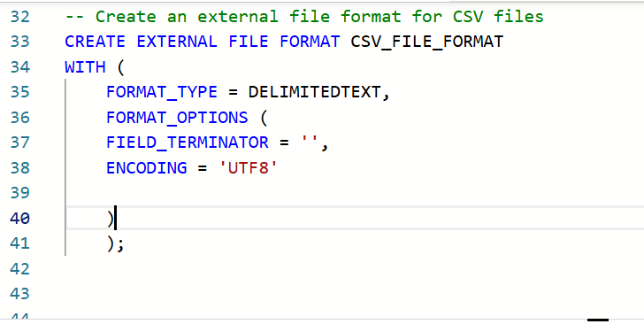

3 things you need to remember when creating external table
- External data source
- External file format
- Location(where you need to store data)
Syn:
CREATE EXTERNAL TABLE census_external_table
(
decennialTime varchar(20),
stateName varchar(100),
countyName varchar(100),
population int,
race varchar(50),
sex varchar(10),
minAge int,
maxAge int
)

WITH (
LOCATION = '/parquet/',
DATA_SOURCE = population_ds,
FILE_FORMAT = census_file_format
)
GO

SELECT TOP 1 * FROM census_external_table
All the code in one place from beginning what we are done:
---create creditional
CREATE DATABASE SCOPED CREDENTIAL shankarcred
WITH IDENTITY = 'Managed Identity';

---create external source
---CREATE EXTERNAL DATA SOURCE MyExternalDataSource
--WITH (
---LOCATION = "https://shstorage1234.dfs.core.windows.net/raw/revenue",
---CREDENTIAL = MyCredential
-- );
CREATE EXTERNAL DATA SOURCE shankardatsource
WITH (
LOCATION = 'https://shstorage1234.dfs.core.windows.net/raw',
CREDENTIAL = shankarcred
);
--openrowset() to read the data from datalake storage
SELECT
*
FROM

OPENROWSET(
BULK 'revenue',
DATA_SOURCE = 'shankardatsource',
FORMAT = 'csv',
PARSER_VERSION = '2.0',
HEADER_ROW = TRUE
) as query1

-- creating external file format

-- Create an external file format for CSV files
CREATE EXTERNAL FILE FORMAT CSV_FILE_FORMAT
WITH (
FORMAT_TYPE = DELIMITEDTEXT,
FORMAT_OPTIONS (
FIELD_TERMINATOR = ',',
ENCODING = 'UTF8'

)
);
----creating External table
CREATE EXTERNAL TABLE external_revenuetable
(
Dealer_ID VARCHAR(1000),
Model_ID VARCHAR(200),
Branch_ID VARCHAR(300),
Date_ID VARCHAR(300),
Units_Sold VARCHAR(300),
Revenue VARCHAR(300)
)

WITH (
LOCATION = 'revenue',
DATA_SOURCE = shankardatsource,
FILE_FORMAT = CSV_FILE_FORMAT

)

SELECT * FROM external_revenuetable;

CETAS:(Create External Table As Select):
In Azure Synapse Analytics, CETAS (Create External Table As Select) is a SQL statement used to create an external table based on the results of a SELECT query. It allows you to define a table that references data stored externally, such as in Azure Data Lake Storage or Azure Blob Storage, without physically copying the data into Synapse.

CREATE EXTERNAL TABLE revenue_cteas
WITH
(
LOCATION = 'cteas_revenue',
DATA_SOURCE = shankardatsource,
FILE_FORMAT = CSV_FILE_FORMAT
)
AS
SELECT
*
FROM

OPENROWSET(
BULK 'revenue',
DATA_SOURCE = 'shankardatsource',
FORMAT = 'csv',
PARSER_VERSION = '2.0',
HEADER_ROW = TRUE
) as query1
Creating Parquet file format:

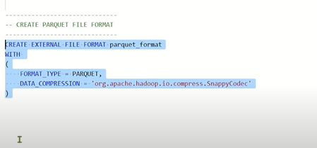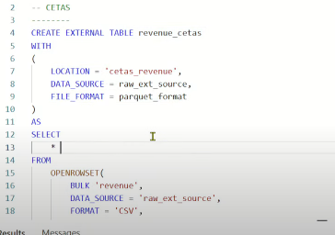

The Exgution flow of the above code is:
First take result of the sql query and transfer the result of sql query into datalake. Than it will create external table on top of datalake

Creating View in synpase analytics:

CREATE VIEW revenue_view

AS
SELECT
*
FROM

OPENROWSET(
BULK 'revenue',
DATA_SOURCE = 'shankardatsource',
FORMAT = 'csv',
PARSER_VERSION = '2.0',
HEADER_ROW = TRUE
) as query1

Loading the data from datalake storage to synapse dedicated pool:
- Copy into 2) CTAS

Copy into:
the COPY statement in Azure Synapse Analytics for loading data from external storage accounts. The COPY statement provides the most flexibility for high-throughput data ingestion into Azure Synapse Analytics.
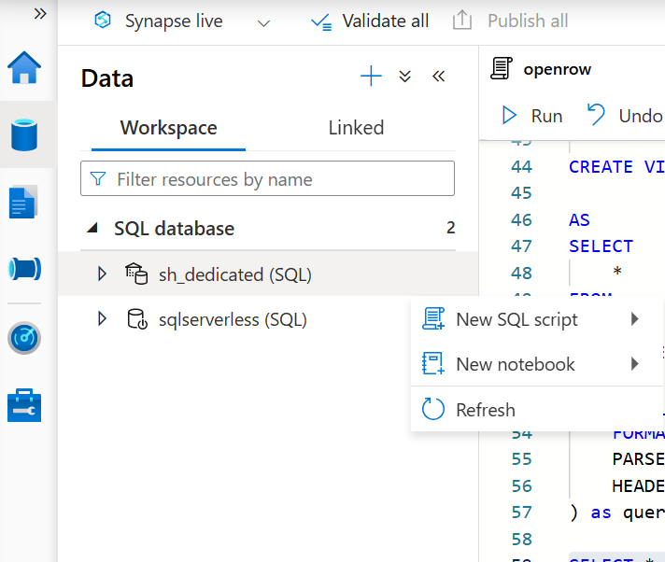

Select the dedicated pool-new sql script

--copy into table to copy the data from datalake to synpase
Creating table:

create TABLE copy_into_table
(

Dealer_ID VARCHAR(1000),
Model_ID VARCHAR(200),
Branch_ID VARCHAR(300),
Date_ID VARCHAR(300),
Units_Sold VARCHAR(300),
Revenue VARCHAR(300)
)

WITH
(
DISTRIBUTION = ROUND_ROBIN
)

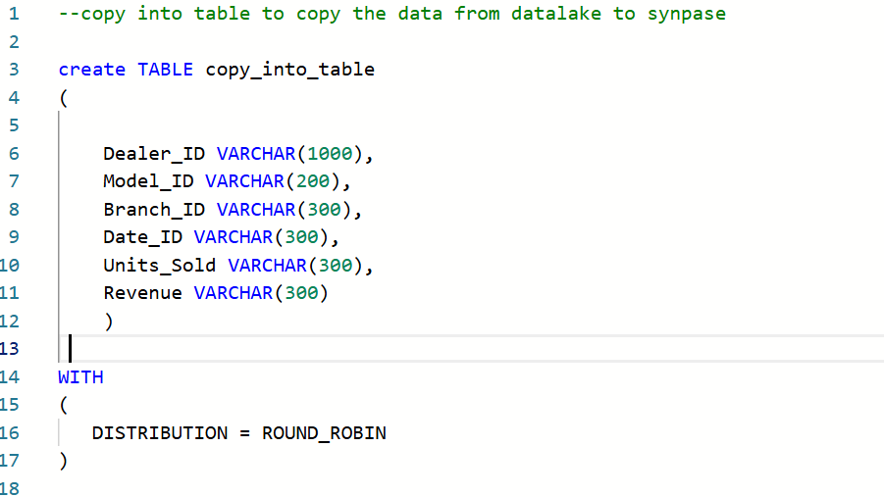

Before loading we need to create credential,and external data source and external file format under dedicated pool previously we created same steps in server less pool
---create creditional
CREATE DATABASE SCOPED CREDENTIAL shankarcred
WITH IDENTITY = 'Managed Identity';

---create external source
---CREATE EXTERNAL DATA SOURCE MyExternalDataSource
--WITH (
---LOCATION = "https://shstorage1234.dfs.core.windows.net/raw/revenue",
---CREDENTIAL = MyCredential
-- );
CREATE EXTERNAL DATA SOURCE shankardatsource
WITH (
LOCATION = 'https://shstorage1234.dfs.core.windows.net/raw',
CREDENTIAL = shankarcred
);

CREATE EXTERNAL FILE FORMAT CSV_FILE_FORMAT
WITH (
FORMAT_TYPE = DELIMITEDTEXT,
FORMAT_OPTIONS (
FIELD_TERMINATOR = '',
ENCODING = 'UTF8'

)
);

Loading the data:

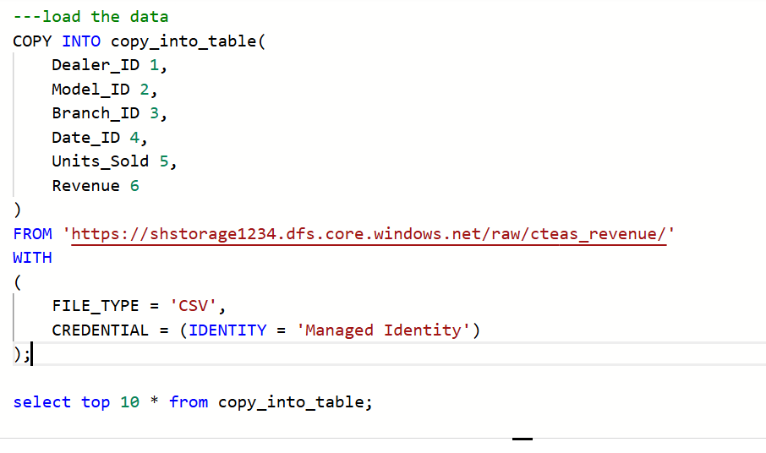

The result will be coming :

- Method to is CTAS (PLOYBASE):

- CREATE EXTERNAL DATA SOURCE shankardatsource1
- WITH (
- LOCATION = 'abfss://raw@shstorage1234.dfs.core.windows.net/',
- CREDENTIAL = shankarcred
- );
- create EXTERNAL TABLE external_poly
- (

- Dealer_ID VARCHAR(1000),
- Model_ID VARCHAR(200),
- Branch_ID VARCHAR(300),
- Date_ID VARCHAR(300),
- Units_Sold VARCHAR(300),
- Revenue VARCHAR(300)
- )

- WITH
- (
- LOCATION = '/cteas_revenue',
- DATA_SOURCE = shankardatsource1,
- FILE_FORMAT = CSV_FILE_FORMAT
- )

Further document from from claude ai:

Complete Azure Synapse Analytics Learning Guide
From Beginner to Professional Level

PART 1: FOUNDATIONS & BASICS
1.1 Introduction to Azure Synapse Analytics
What is Azure Synapse Analytics?
- Unified analytics platform combining data warehousing, big data analytics, and data integration
- Evolution of Azure SQL Data Warehouse
- Enterprise-scale analytics service for petabyte-scale data
- Supports both serverless and dedicated resources
Key Components:
- Synapse Studio: Web-based IDE for development and management
- SQL Pools: Dedicated and serverless SQL compute
- Apache Spark Pools: Big data processing engine
- Pipelines: Data integration and orchestration
- Data Explorer: Real-time analytics (KQL)
Architecture Overview:
- Control Node: Query distribution and coordination
- Compute Nodes: Parallel processing units
- Storage: Azure Data Lake Storage Gen2 integration
- MPP (Massively Parallel Processing) architecture
1.2 Setting Up Azure Synapse
Prerequisites:
- Azure subscription
- Resource group
- Storage account (ADLS Gen2)
- Proper permissions (Contributor/Owner)
Workspace Creation:
-- Basic workspace setup requires:
-- 1. Workspace name
-- 2. Region selection
-- 3. Data Lake Storage Gen2 account
-- 4. File system name
-- 5. Authentication method
Initial Configuration:
- Security settings
- Networking configuration
- Git integration setup
- Linked services configuration
1.3 Synapse Studio Overview
Main Sections:
- Home: Dashboard and quick actions
- Data: Data sources and datasets
- Develop: SQL scripts, notebooks, data flows
- Integrate: Pipelines and activities
- Monitor: Job monitoring and metrics
- Manage: Resource management and security
Navigation Tips:
- Workspace switcher
- Resource explorer
- Activity monitoring
- Collaboration features

PART 2: SQL POOLS (DEDICATED)
2.1 Dedicated SQL Pool Fundamentals
What is a Dedicated SQL Pool?
- Formerly SQL Data Warehouse
- Fixed compute resources (DWUs - Data Warehouse Units)
- Columnar storage with clustered columnstore indexes
- Enterprise-grade data warehousing solution
Performance Levels:
- DW100c to DW30000c
- Scaling options (pause/resume/scale)
- Cost considerations
Architecture Components:
- Control Node: Query parsing and optimization
- Compute Nodes: Data processing (1-60 nodes)
- Data Movement Service (DMS): Data shuffling
- Storage: Premium SSD with local caching
2.2 Table Design and Distribution
Distribution Strategies:
1. Hash Distribution:
CREATE TABLE Sales_Hash
(
ProductID int,
CustomerID int,
SalesAmount decimal(10,2),
OrderDate datetime
)
WITH
(
DISTRIBUTION = HASH(CustomerID),
CLUSTERED COLUMNSTORE INDEX
);
2. Round Robin Distribution:
CREATE TABLE Sales_RoundRobin
(
ProductID int,
CustomerID int,
SalesAmount decimal(10,2)
)
WITH
(
DISTRIBUTION = ROUND_ROBIN,
CLUSTERED COLUMNSTORE INDEX
);
3. Replicated Distribution:
CREATE TABLE DimProduct
(
ProductID int,
ProductName varchar(100),
Category varchar(50)
)
WITH
(
DISTRIBUTION = REPLICATE,
CLUSTERED COLUMNSTORE INDEX
);
Distribution Guidelines:
- Hash: Large fact tables (>2GB per distribution)
- Round Robin: Staging tables, no obvious join key
- Replicated: Small dimension tables (<2GB total)
2.3 Indexing Strategies
Clustered Columnstore Index (Default):
CREATE TABLE Sales_CCI
(
OrderID int,
CustomerID int,
ProductID int,
Quantity int,
Amount decimal(10,2)
)
WITH
(
DISTRIBUTION = HASH(CustomerID),
CLUSTERED COLUMNSTORE INDEX
);
Clustered Index:
CREATE TABLE Customer_CI
(
CustomerID int,
FirstName varchar(50),
LastName varchar(50),
Email varchar(100)
)
WITH
(
DISTRIBUTION = HASH(CustomerID),
CLUSTERED INDEX (CustomerID)
);
Heap Tables:
CREATE TABLE Staging_Heap
(
Col1 varchar(100),
Col2 varchar(100),
Col3 varchar(100)
)
WITH
(
DISTRIBUTION = ROUND_ROBIN,
HEAP
);
Non-Clustered Indexes:
-- After table creation
CREATE NONCLUSTERED INDEX IX_Customer_Email
ON Customer_CI (Email);
2.4 Partitioning
Range Partitioning:
CREATE TABLE Sales_Partitioned
(
OrderDate date,
CustomerID int,
Amount decimal(10,2)
)
WITH
(
DISTRIBUTION = HASH(CustomerID),
CLUSTERED COLUMNSTORE INDEX,
PARTITION (OrderDate RANGE RIGHT FOR VALUES
('2023-01-01', '2023-02-01', '2023-03-01', '2023-04-01'))
);
Partition Management:
-- Split partition
ALTER TABLE Sales_Partitioned
SPLIT RANGE ('2023-05-01');

-- Merge partitions
ALTER TABLE Sales_Partitioned
MERGE RANGE ('2023-02-01');

-- Switch partition
ALTER TABLE Sales_Partitioned
SWITCH PARTITION 2 TO Staging_Table PARTITION 2;
2.5 Data Loading Strategies
COPY Command (Recommended):
COPY INTO Sales_Table
FROM 'https://storage.dfs.core.windows.net/data/sales/'
WITH (
FILE_TYPE = 'CSV',
CREDENTIAL = (IDENTITY = 'Managed Identity'),
FIELDTERMINATOR = ',',
ROWTERMINATOR = '\n',
FIRSTROW = 2,
ERRORFILE = 'https://storage.dfs.core.windows.net/errors/'
);
PolyBase External Tables:
-- Create external data source
CREATE EXTERNAL DATA SOURCE AzureStorage
WITH (
LOCATION = 'abfss://data@storage.dfs.core.windows.net/',
CREDENTIAL = StorageCredential
);

-- Create external file format
CREATE EXTERNAL FILE FORMAT CSVFormat
WITH (
FORMAT_TYPE = DELIMITEDTEXT,
FORMAT_OPTIONS (
FIELD_TERMINATOR = ',',
STRING_DELIMITER = '"',
FIRST_ROW = 2
)
);

-- Create external table
CREATE EXTERNAL TABLE ExtSales
(
OrderID int,
CustomerID int,
Amount decimal(10,2)
)
WITH (
LOCATION = 'sales/',
DATA_SOURCE = AzureStorage,
FILE_FORMAT = CSVFormat
);

-- Load data using CTAS
CREATE TABLE Sales_Internal
WITH (
DISTRIBUTION = HASH(CustomerID),
CLUSTERED COLUMNSTORE INDEX
)
AS SELECT * FROM ExtSales;
Bulk Insert:
BULK INSERT Sales_Table
FROM 'sales_data.csv'
WITH (
DATA_SOURCE = 'AzureStorage',
FORMAT = 'CSV',
FIRSTROW = 2,
FIELDTERMINATOR = ',',
ROWTERMINATOR = '\n'
);

PART 3: SERVERLESS SQL POOLS
3.1 Serverless SQL Pool Fundamentals
What is Serverless SQL Pool?
- Pay-per-query model
- No infrastructure management
- Automatic scaling
- Query data in-place (data lake)
- Built-in endpoint (always available)
Use Cases:
- Data exploration and discovery
- Ad-hoc analytics
- Data lake querying
- Logical data warehousing
- Cost-effective for sporadic workloads
Limitations:
- No data persistence
- Limited to 30 concurrent queries
- 4-hour query timeout
- No write operations to external storage
3.2 Querying Data Lake Files
CSV Files:
SELECT TOP 100 *
FROM OPENROWSET(
BULK 'https://storage.dfs.core.windows.net/data/sales.csv',
FORMAT = 'CSV',
PARSER_VERSION = '2.0',
HEADER_ROW = TRUE,
FIELDTERMINATOR = ',',
ROWTERMINATOR = '\n'
) AS result;
JSON Files:
SELECT
JSON_VALUE(jsonContent, '$.name') AS ProductName,
JSON_VALUE(jsonContent, '$.price') AS Price
FROM OPENROWSET(
BULK 'https://storage.dfs.core.windows.net/data/products.json',
FORMAT = 'CSV',
FIELDTERMINATOR = '0x0b',
FIELDQUOTE = '0x0b',
ROWTERMINATOR = '0x0a'
) WITH (jsonContent varchar(8000)) AS result;
Parquet Files:
SELECT *
FROM OPENROWSET(
BULK 'https://storage.dfs.core.windows.net/data/sales.parquet',
FORMAT = 'PARQUET'
) AS result;
Delta Lake:
SELECT *
FROM OPENROWSET(
BULK 'https://storage.dfs.core.windows.net/data/delta-table/',
FORMAT = 'DELTA'
) AS result;
3.3 External Tables and Views
External Data Source:
CREATE EXTERNAL DATA SOURCE DataLakeSource
WITH (
LOCATION = 'https://storage.dfs.core.windows.net/data/'
);
External File Format:
CREATE EXTERNAL FILE FORMAT ParquetFormat
WITH (
FORMAT_TYPE = PARQUET
);
External Table:
CREATE EXTERNAL TABLE ExtSalesData
(
OrderID int,
CustomerID int,
OrderDate date,
Amount decimal(10,2)
)
WITH (
LOCATION = 'sales/',
DATA_SOURCE = DataLakeSource,
FILE_FORMAT = ParquetFormat
);
Views for Abstraction:
CREATE VIEW SalesView AS
SELECT
OrderID,
CustomerID,
OrderDate,
Amount,
YEAR(OrderDate) AS OrderYear,
MONTH(OrderDate) AS OrderMonth
FROM ExtSalesData
WHERE Amount > 0;
3.4 Data Types and Schema Inference
Automatic Schema Inference:
-- Parquet files automatically infer schema
SELECT *
FROM OPENROWSET(
BULK 'https://storage.dfs.core.windows.net/data/*.parquet',
FORMAT = 'PARQUET'
) AS result;
Explicit Schema Definition:
SELECT *
FROM OPENROWSET(
BULK 'https://storage.dfs.core.windows.net/data/sales.csv',
FORMAT = 'CSV',
PARSER_VERSION = '2.0'
) WITH (
OrderID int,
CustomerID int,
OrderDate date,
Amount decimal(10,2)
) AS result;

PART 4: APACHE SPARK POOLS
4.1 Spark Pool Fundamentals
What are Spark Pools?
- Managed Apache Spark clusters
- Auto-scaling capabilities
- Multiple language support (Python, Scala, .NET, SQL)
- Integration with Azure services
- Optimized for big data processing
Spark Pool Configuration:
- Node sizes (Small, Medium, Large, XLarge, XXLarge)
- Auto-scaling settings (min/max nodes)
- Auto-pause configuration
- Apache Spark version selection
Session Management:
- Session isolation
- Resource allocation
- Automatic cleanup
- Session monitoring
4.2 Notebooks and Development
Creating Notebooks:
# Python cell example
import pandas as pd
from pyspark.sql import SparkSession

# Initialize Spark session
spark = SparkSession.builder.appName("DataAnalysis").getOrCreate()

# Read data from Data Lake
df = spark.read.parquet("abfss://data@storage.dfs.core.windows.net/sales/")
df.show()
Data Manipulation:
# Data transformations
from pyspark.sql.functions import col, sum, avg, count

# Aggregations
sales_summary = df.groupBy("CustomerID") \
.agg(
sum("Amount").alias("TotalSales"),
avg("Amount").alias("AvgSales"),
count("OrderID").alias("OrderCount")
)

sales_summary.show()
Spark SQL:
-- SQL cell in notebook
CREATE OR REPLACE TEMPORARY VIEW sales_view
USING PARQUET
OPTIONS (
path "abfss://data@storage.dfs.core.windows.net/sales/"
);

SELECT
CustomerID,
SUM(Amount) as TotalSales,
COUNT(*) as OrderCount
FROM sales_view
GROUP BY CustomerID
ORDER BY TotalSales DESC;
4.3 Data Processing Patterns
ETL Pipeline Example:
# Extract
source_df = spark.read \
.option("header", "true") \
.option("inferSchema", "true") \
.csv("abfss://raw@storage.dfs.core.windows.net/input/")

# Transform
from pyspark.sql.functions import when, col, current_timestamp

transformed_df = source_df \
.withColumn("Amount", col("Amount").cast("decimal(10,2)")) \
.withColumn("OrderDate", col("OrderDate").cast("date")) \
.withColumn("Status",
when(col("Amount") > 1000, "High Value")
.when(col("Amount") > 100, "Medium Value")
.otherwise("Low Value")) \
.withColumn("ProcessedDate", current_timestamp()) \
.filter(col("Amount") > 0)

# Load
transformed_df.write \
.mode("overwrite") \
.parquet("abfss://processed@storage.dfs.core.windows.net/output/")
Stream Processing:
# Structured Streaming
from pyspark.sql.functions import window, col

# Read streaming data
streaming_df = spark \
.readStream \
.format("delta") \
.load("abfss://streaming@storage.dfs.core.windows.net/input/")

# Process stream
windowed_counts = streaming_df \
.withWatermark("timestamp", "10 minutes") \
.groupBy(
window(col("timestamp"), "5 minutes", "1 minute"),
col("category")
) \
.count()

# Write stream
query = windowed_counts \
.writeStream \
.format("delta") \
.outputMode("append") \
.option("checkpointLocation", "/checkpoint/path") \
.start("abfss://output@storage.dfs.core.windows.net/results/")
4.4 Machine Learning Integration
MLlib Example:
from pyspark.ml.feature import VectorAssembler
from pyspark.ml.regression import LinearRegression
from pyspark.ml import Pipeline

# Prepare features
assembler = VectorAssembler(
inputCols=["feature1", "feature2", "feature3"],
outputCol="features"
)

# Create model
lr = LinearRegression(
featuresCol="features",
labelCol="target"
)

# Create pipeline
pipeline = Pipeline(stages=[assembler, lr])

# Train model
model = pipeline.fit(training_df)

# Make predictions
predictions = model.transform(test_df)
Azure ML Integration:
from azureml.core import Workspace, Model
import mlflow

# Connect to Azure ML
ws = Workspace.from_config()

# Log model with MLflow
mlflow.set_tracking_uri(ws.get_mlflow_tracking_uri())
mlflow.set_experiment("synapse-experiment")

with mlflow.start_run():
# Train model
model = train_model(data)

# Log metrics
mlflow.log_metric("rmse", rmse_score)
mlflow.log_metric("r2", r2_score)

# Log model
mlflow.sklearn.log_model(model, "model")

PART 5: DATA INTEGRATION & PIPELINES
5.1 Pipeline Fundamentals
What are Synapse Pipelines?
- Data integration and orchestration service
- Based on Azure Data Factory
- Visual designer interface
- Support for 90+ connectors
- Scheduling and monitoring capabilities
Pipeline Components:
- Activities: Individual tasks (Copy, Transform, Execute)
- Datasets: Data structure definitions
- Linked Services: Connection information
- Triggers: Schedule or event-based execution
- Parameters: Dynamic pipeline execution
5.2 Copy Activity
Basic Copy Activity:
{
"name": "CopyFromBlobToSynapse",
"type": "Copy",
"inputs": [
{
"referenceName": "SourceDataset",
"type": "DatasetReference"
}
],
"outputs": [
{
"referenceName": "SinkDataset",
"type": "DatasetReference"
}
],
"typeProperties": {
"source": {
"type": "DelimitedTextSource",
"storeSettings": {
"type": "AzureBlobStorageReadSettings",
"recursive": true
}
},
"sink": {
"type": "SqlDWSink",
"preCopyScript": "TRUNCATE TABLE dbo.SalesData",
"tableOption": "autoCreate"
}
}
}
Advanced Copy Settings:
- Parallel copying
- Staged copy (PolyBase)
- Data type mapping
- Column mapping
- Pre/post copy scripts
5.3 Data Flows
Mapping Data Flow:
{
"name": "TransformSalesData",
"type": "MappingDataFlow",
"typeProperties": {
"sources": [
{
"name": "SalesSource",
"dataset": {
"referenceName": "SalesDataset",
"type": "DatasetReference"
}
}
],
"transformations": [
{
"name": "FilterValidRecords",
"type": "Filter",
"expression": "Amount > 0 && !isNull(CustomerID)"
},
{
"name": "DeriveColumns",
"type": "DerivedColumn",
"columns": [
{
"name": "TaxAmount",
"expression": "Amount * 0.1"
},
{
"name": "OrderYear",
"expression": "year(OrderDate)"
}
]
},
{
"name": "AggregateByCustomer",
"type": "Aggregate",
"groupBy": ["CustomerID"],
"aggregates": [
{
"name": "TotalSales",
"expression": "sum(Amount)"
},
{
"name": "OrderCount",
"expression": "count()"
}
]
}
],
"sinks": [
{
"name": "OutputSink",
"dataset": {
"referenceName": "OutputDataset",
"type": "DatasetReference"
}
}
]
}
}
5.4 Control Flow Activities
Conditional Execution:
{
"name": "ConditionalPipeline",
"activities": [
{
"name": "CheckFileExists",
"type": "GetMetadata",
"typeProperties": {
"dataset": {
"referenceName": "InputFile",
"type": "DatasetReference"
},
"fieldList": ["exists"]
}
},
{
"name": "ProcessIfExists",
"type": "IfCondition",
"dependsOn": [
{
"activity": "CheckFileExists",
"dependencyConditions": ["Succeeded"]
}
],
"typeProperties": {
"expression": {
"value": "@activity('CheckFileExists').output.exists",
"type": "Expression"
},
"ifTrueActivities": [
{
"name": "CopyData",
"type": "Copy"
}
],
"ifFalseActivities": [
{
"name": "LogError",
"type": "WebActivity"
}
]
}
}
]
}
Loop Activities:
{
"name": "ProcessMultipleFiles",
"type": "ForEach",
"typeProperties": {
"items": {
"value": "@pipeline().parameters.FileList",
"type": "Expression"
},
"isSequential": false,
"batchCount": 20,
"activities": [
{
"name": "ProcessFile",
"type": "Copy",
"typeProperties": {
"source": {
"type": "DelimitedTextSource",
"storeSettings": {
"type": "AzureBlobStorageReadSettings",
"path": "@item()"
}
}
}
}
]
}
}
5.5 Triggers and Scheduling
Schedule Trigger:
{
"name": "DailyTrigger",
"type": "ScheduleTrigger",
"typeProperties": {
"recurrence": {
"frequency": "Day",
"interval": 1,
"startTime": "2024-01-01T02:00:00Z",
"timeZone": "UTC",
"schedule": {
"hours": [2],
"minutes": [0]
}
}
}
}
Event-based Trigger:
{
"name": "BlobEventTrigger",
"type": "BlobEventsTrigger",
"typeProperties": {
"blobPathBeginsWith": "/container/data/",
"blobPathEndsWith": ".csv",
"ignoreEmptyBlobs": true,
"scope": "/subscriptions/{subscription}/resourceGroups/{rg}/providers/Microsoft.Storage/storageAccounts/{account}",
"events": ["Microsoft.Storage.BlobCreated"]
}
}

PART 6: SECURITY & GOVERNANCE
6.1 Authentication and Access Control
Authentication Methods:
- Azure Active Directory (AAD)
- Managed Identity
- Service Principal
- SAS Tokens
- Storage Account Keys
Role-Based Access Control (RBAC):
-- Synapse Administrator: Full access
-- Synapse Contributor: Manage resources
-- Synapse Reader: Read-only access
-- Custom roles for specific needs

-- Grant database roles
EXEC sp_addrolemember 'db_datareader', 'user@domain.com';
EXEC sp_addrolemember 'db_datawriter', 'user@domain.com';
EXEC sp_addrolemember 'db_owner', 'admin@domain.com';
SQL-level Security:
-- Create login and user
CREATE LOGIN [user@domain.com] FROM EXTERNAL PROVIDER;
CREATE USER [user@domain.com] FOR LOGIN [user@domain.com];

-- Grant specific permissions
GRANT SELECT ON Sales_Table TO [user@domain.com];
GRANT INSERT, UPDATE ON Customer_Table TO [user@domain.com];
GRANT EXECUTE ON SCHEMA::dbo TO [app_service_principal];
6.2 Data Encryption
Encryption at Rest:
- Automatic encryption with service-managed keys
- Customer-managed keys (CMK) support
- Always Encrypted for sensitive columns
-- Always Encrypted example
CREATE COLUMN MASTER KEY CustomerCMK
WITH (
KEY_STORE_PROVIDER_NAME = 'AZURE_KEY_VAULT',
KEY_PATH = 'https://vault.vault.azure.net/keys/CMK/version'
);

CREATE COLUMN ENCRYPTION KEY CustomerCEK
WITH VALUES (
COLUMN_MASTER_KEY = CustomerCMK,
ALGORITHM = 'RSA_OAEP',
ENCRYPTED_VALUE = 0x...
);

CREATE TABLE Customers (
CustomerID int IDENTITY(1,1),
FirstName varchar(50),
LastName varchar(50),
SSN char(11) ENCRYPTED WITH (
COLUMN_ENCRYPTION_KEY = CustomerCEK,
ENCRYPTION_TYPE = Deterministic,
ALGORITHM = 'AEAD_AES_256_CBC_HMAC_SHA_256'
)
);
Encryption in Transit:
- TLS 1.2 for all connections
- Force encryption settings
- Certificate validation
6.3 Row-Level Security
RLS Implementation:
-- Create security function
CREATE FUNCTION dbo.SecurityPredicate(@UserName sysname)
RETURNS TABLE
WITH SCHEMABINDING
AS
RETURN SELECT 1 AS Result
WHERE @UserName = USER_NAME() OR IS_MEMBER('db_owner') = 1;

-- Create security policy
CREATE SECURITY POLICY SalesSecurityPolicy
ADD FILTER PREDICATE dbo.SecurityPredicate(UserName) ON dbo.SalesData,
ADD BLOCK PREDICATE dbo.SecurityPredicate(UserName) ON dbo.SalesData
WITH (STATE = ON);
6.4 Dynamic Data Masking
DDM Configuration:
-- Apply masking to sensitive columns
ALTER TABLE Customers
ALTER COLUMN SSN ADD MASKED WITH (FUNCTION = 'partial(0,"XXX-XX-",4)');

ALTER TABLE Customers
ALTER COLUMN Email ADD MASKED WITH (FUNCTION = 'email()');

ALTER TABLE Customers
ALTER COLUMN CreditCardNumber ADD MASKED WITH (FUNCTION = 'partial(4,"XXXX-XXXX-XXXX-",4)');

-- Grant unmask permission
GRANT UNMASK TO [privileged_user@domain.com];
6.5 Auditing and Compliance
SQL Auditing:
-- Enable auditing at server level
-- Configure in Azure portal or ARM template

-- Custom audit actions
SELECT
event_time,
action_name,
succeeded,
database_name,
schema_name,
object_name,
client_ip,
application_name,
principal_name
FROM sys.fn_get_audit_file('https://storage.blob.core.windows.net/audit/', NULL, NULL);
Compliance Features:
- SOC 1, SOC 2, ISO 27001 certification
- GDPR compliance tools
- HIPAA compliance support
- Data residency options

PART 7: PERFORMANCE OPTIMIZATION
7.1 Query Performance Tuning
Execution Plan Analysis:
-- Enable actual execution plan
SET STATISTICS IO ON;
SET STATISTICS TIME ON;

EXPLAIN (ANALYZE true, BUFFERS true)
SELECT
c.CustomerName,
SUM(s.Amount) as TotalSales
FROM Customers c
JOIN Sales s ON c.CustomerID = s.CustomerID
WHERE s.OrderDate >= '2023-01-01'
GROUP BY c.CustomerName
ORDER BY TotalSales DESC;
Query Optimization Techniques:
-- Use appropriate WHERE clauses
SELECT * FROM Sales
WHERE OrderDate >= '2023-01-01' -- Partition elimination
AND CustomerID IN (SELECT CustomerID FROM ActiveCustomers); -- Efficient joins

-- Avoid SELECT *
SELECT CustomerID, OrderDate, Amount
FROM Sales
WHERE OrderDate >= '2023-01-01';

-- Use EXISTS instead of IN for large datasets
SELECT * FROM Customers c
WHERE EXISTS (
SELECT 1 FROM Sales s
WHERE s.CustomerID = c.CustomerID
AND s.OrderDate >= '2023-01-01'
);
7.2 Columnstore Index Optimization
Columnstore Health Monitoring:
-- Check columnstore segment quality
SELECT
t.name AS TableName,
i.name AS IndexName,
rg.row_group_id,
rg.state_desc,
rg.total_rows,
rg.deleted_rows,
rg.size_in_bytes
FROM sys.dm_pdw_nodes_column_store_row_groups rg
JOIN sys.pdw_nodes_tables pt ON rg.object_id = pt.object_id
JOIN sys.tables t ON pt.name = t.name
JOIN sys.indexes i ON t.object_id = i.object_id
WHERE rg.state_desc = 'COMPRESSED'
ORDER BY t.name, rg.row_group_id;
Index Maintenance:
-- Rebuild columnstore index
ALTER INDEX CCI_Sales ON Sales REBUILD;

-- Reorganize columnstore index
ALTER INDEX CCI_Sales ON Sales REORGANIZE;

-- Optimize for bulk load
ALTER INDEX CCI_Sales ON Sales REBUILD
WITH (MAXDOP = 1, DATA_COMPRESSION = COLUMNSTORE);
7.3 Statistics Management
Create and Update Statistics:
-- Create statistics
CREATE STATISTICS stat_customer_id ON Sales (CustomerID);
CREATE STATISTICS stat_order_date ON Sales (OrderDate);
CREATE STATISTICS stat_multi_column ON Sales (CustomerID, OrderDate);

-- Update statistics
UPDATE STATISTICS Sales stat_customer_id;
UPDATE STATISTICS Sales WITH FULLSCAN;

-- Auto-create statistics
ALTER DATABASE MyDatabase
SET AUTO_CREATE_STATISTICS ON;
ALTER DATABASE MyDatabase
SET AUTO_UPDATE_STATISTICS ON;
Statistics Monitoring:
-- Check statistics information
SELECT
t.name AS TableName,
s.name AS StatsName,
s.stats_id,
s.auto_created,
s.user_created,
sp.last_updated,
sp.rows,
sp.rows_sampled,
sp.modification_counter
FROM sys.stats s
JOIN sys.tables t ON s.object_id = t.object_id
CROSS APPLY sys.dm_db_stats_properties(s.object_id, s.stats_id) sp
WHERE t.name = 'Sales'
ORDER BY s.name;
7.4 Resource Management
Workload Management:
-- Create workload classifier
CREATE WORKLOAD CLASSIFIER ETL_Classifier
WITH (
WORKLOAD_GROUP = 'ETL_Group',
MEMBERNAME = 'ETL_User',
IMPORTANCE = HIGH
);

-- Create workload group
CREATE WORKLOAD GROUP ETL_Group

